Path Planning and Comparative Heuristic Search in Stochastic Grid Enviroments

Zachariah McCullough
School of Computer Science and Computer Engineering
The University of Southern Mississippi
Hattiesburg, MS, USA
zachariah.mccullough@usm.edu

Abstract— One of the most important topics in the artificial intelligence space is navigation and path planning, especially for complex environments. In this paper, I will be using BFS, UCS and A* search in a randomized grid environment. Additionally, I will be using Manhattan and Euclidean heuristics to discover the efficiency between the two. The grid being used has a randomized density of between 12-24%, in which the agent is bound four directions (up, left, right, down).
Keywords — Path Planning, A* Search, BFS, UCS, Heuristic Optimization, Grid World.

Introduction
Path planning problem is perhaps one of the most fundamental problems that relate to an independent agent performing computations and calculations to establish the most optimal or near-optimal path through the given space from the known initial position to a target final position without any collision with the environment [1] [2] [3]. The mathematical formulation of navigation in the context of algorithmic game theory and robotics involves graph search problems on state spaces [2]. Both BFS and UCS are optimal in terms of cost in traversal but because of the exhaustive approach, the computational complexity is higher [1, p. 82, 114] [4, p. 595]. The heuristic search algorithms, such as A* search, make use of heuristics of the domain to perform the search process to reach the goal [5, p. 508] [6]. This paper discusses the development and implementation of option 1 (Path planning with Heuristic search) with benchmark framework in Python for stochastic maps [7] [8] [9].

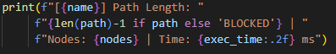
problem formulation & environment
The project uses a custom Python class DeterministicGridWorld to create and manage the map [10] [9]

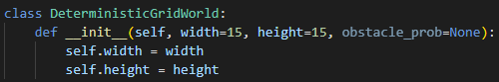
*Comments removed for view

How the Grid works
- State Space (S): Discrete W x H with an X,Y coordinate pair
- Action Space (A): only left right, up and down
- Edge Costs: Every valid step incurs a cost of 1; Cost(Starting State, Action, New State) ~ c(s,a,s’) = 1.0 [11] [12] [13]

- Start and Terminal Goals: The starting point is always the top left corner (0,0) with the ending point being bottom right (W-1, H-1) [3, p. 202]

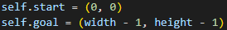

Stochastic Hazards and Robust Blocked-Path Handling
Each map (10X10, 15X15, 20X20, 25X25) populates obstacles randomly [14, p. 3]
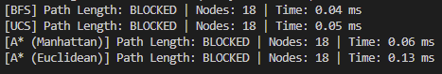
This makes each map behave differently, with some maps being BLOCKED entirely. This simulates real world scenarios where paths can be blocked [13, p. 640] [15] [16]

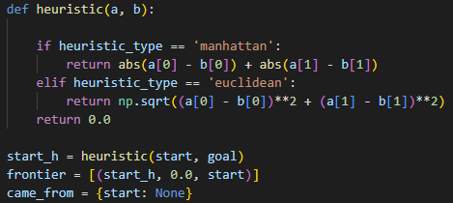

technical approach & implementation
The code implements BFS, UCS and A Search through heapq and collections.deque for queue priority and efficiency [17] [18] [19]

Breadth-First Search (BFS)
BFS analyses the graph layer by layer using FIFO (First-In-First-Out) [18] [4] [20]. Since all edge weights are identical (1.0), it will always find the most optimal solution [1] [4] [21]. Despite this, it lacks any true sense of direction and its exploration is isotropic in nature [1] [4]
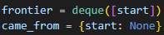

Uniform Cost Search (UCS)
UCS shares a similar traversing properties as BFS, however it is more cost aware for unequally weighted networks [1] [11] [19]. UCS uses a min-priority queue (heapq) and will always uses the lowest cumulative cost g(n) [17] [11] [22]
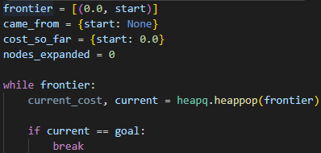

*Comments removed for view

A* Search Algorithm
A* uses informed guidance to evaluate nodes [1, p. 11] [23] [11]
f (n) = g (n) + h (n)
g (n) = tracks the exact path cost (0,0)
h (n) – remaining cost of the goal [1] [23] [24]
Two different heuristics approaches are used in the code to evaluate distance [1] [24] [25]
- Manhattan Distance: The model is bound by four movements (Left, Right, Up, Down). Because of this the exact distance is never over / overestimated. It is optimal and consistent [24] [26]
- Euclidean Distance: This ignores obstacles, will always under-estimate cost and will force A* to search through nodes unnecessarily [3] [24]

*Comments removed for view

visualization and executive framework

- Static Map:
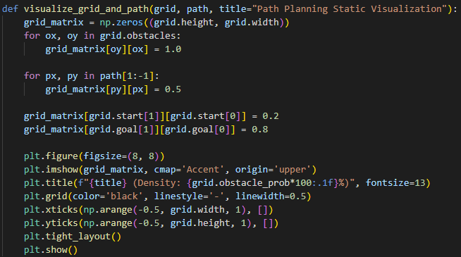
Two-dimensional representation of the grid, and applies discrete color-mapping weights to distinguish empty space, obstacles, the solved path and start coordinates
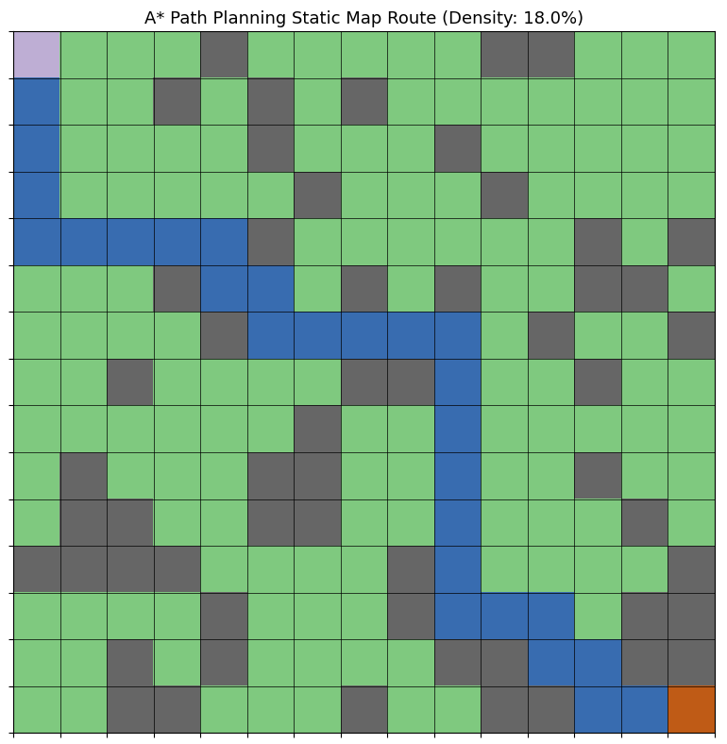
*Comments removed for view

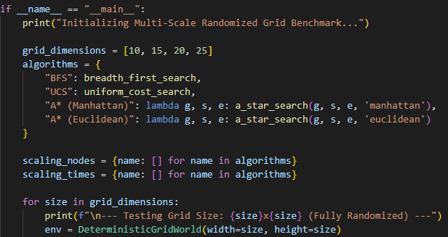
- Step by Step Traversal:
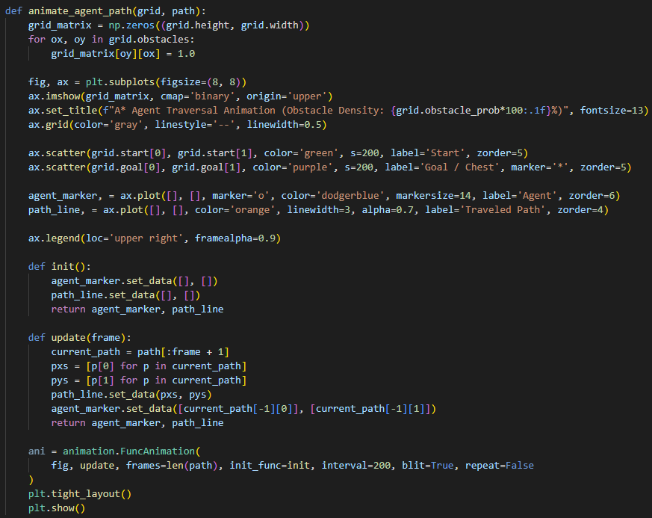
Renders frame by frame to solve the path
*Comments removed for view
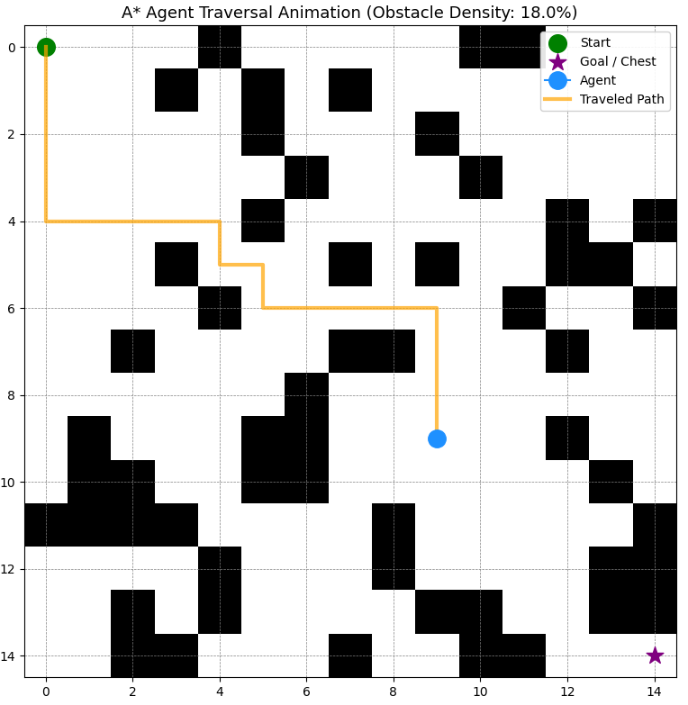

- Master Suite:
Single-pass test, provides comparison graphs along with the two-dimensional grid and animation

*Comments removed for view

- Monte Carlo Benchmarking:
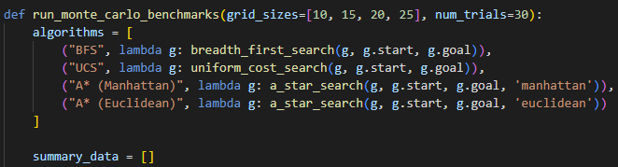
Stress tests 30 independent trails and gives success rates, node counts and execution times

results
Because the maps are generated randomly upon every run, repeating runs will yield different paths, outputs and latencies.

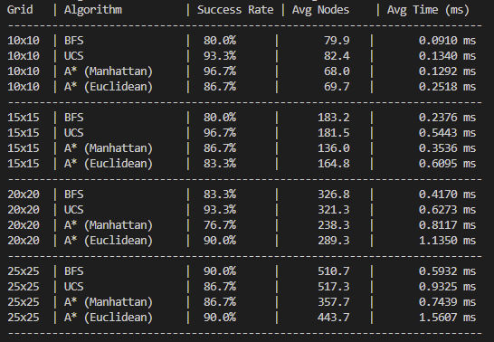
Monte Carlo Results:
*Figure 1 (N-30 Trails per scale)

Because layouts are generated randonaly, a 30 run Monte Carlo benchamrking smooths out the random spikes in map structure to show true and relaible performance [27] [28]

Manhatten consistenlty explores fewer states (Avg, Nodes) than Euclidean [24, p. 63] [26, p. 27]. This is due to the fact that Manhattan is only bound by first directions and provides a tigher guide to the target

Euclideans is valid, but because it calculates the square roots for every node [19] [24] it drives CPU usage

BFS and UCS lack a sense of direction [4, p. 594] causing both of them to expand nodes unecessarily (see figure 1)

Master Execution Results (Single Run)
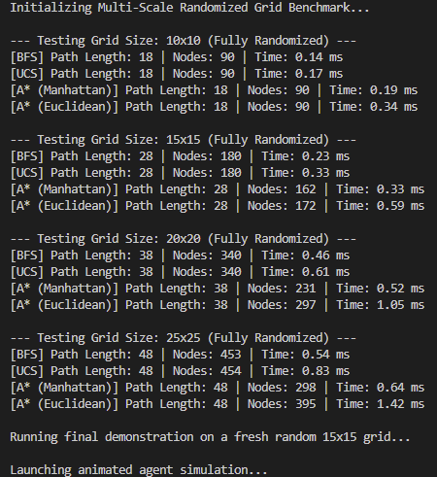
*Figure 2 (Single Run)

On the smaller 10X10 grid movment is heavily constrained leading to the identicle 90 nodes. Out of this bottleneck heuristic direction takes over [29] [26]

Manhattan achieves the sharpest state pruning state (see figure 3), and Eucilidean has the highest CPU penalty [24, p. 63] [26, p. 27]

Because the grid is randomized, a small percentage of runs will block the goal completely (see section 2, part B) [30]

As illustrated by Figure 3 and Figure 4, the state space grows linearly with grid size. BFS achieves consistently low execution times with zero heuristic calculation overhead [31] [32] [33]. However, its failure of having a sense of direction means it expands nodes exponentially [34] [35]

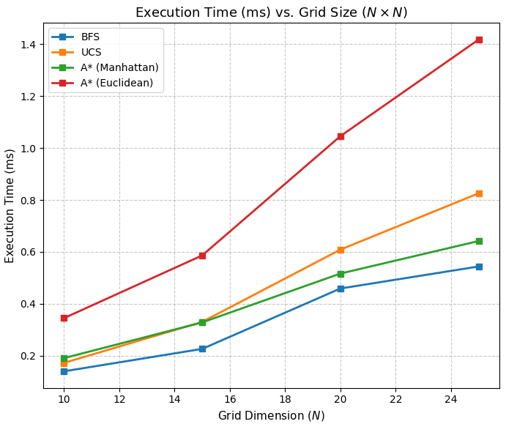
*Figure 3
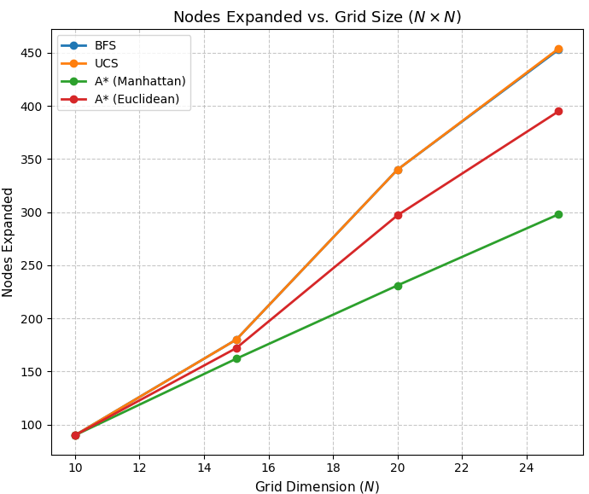
*Figure 4

Conclusions and future work
This paper analyzed the scaling behavior of unguided (BFS, UCS) and guided (A*) search algorithms in stochastic environments. It clearly demonstrated that A* Search with Manhattan is more efficient in terms of reducing state space while also maintaining low computational time. Future work will include 8-connectivity of grids (4 cardinal / 4 diagonal).

References

- S. Russell and P. Norvig, Artificial Intelligence: A Modern Approach, 4th ed. Hoboken, NJ: Pearson, 2020.
- S. Thrun, W. Burgard, and D. Fox, Probabilistic Robotics. Cambridge, MA: MIT Press, 2005. [Online]. Available: https://docs.ufpr.br/~danielsantos/ProbabilisticRobotics.pdf
- S. M. LaValle, Planning Algorithms. Cambridge, U.K.: Cambridge University Press, 2006. [Online]. Available: https://lavalle.pl/planning/book.pdf
- T. H. Cormen, C. E. Leiserson, R. L. Rivest, and C. Stein, Introduction to Algorithms, 4th ed. Cambridge, MA: MIT Press, 2022. [Online]. Available: https://www.cs.mcgill.ca/~akroit/math/compsci/Cormen%20Introduction%20to%20Algorithms.pdf
- R. Dechter and J. Pearl, "Generalized best-first search strategies and the optimality of A*," Journal of the ACM, vol. 32, no. 3, pp. 505–536, 1985. [Online]. Available: https://dl.acm.org/doi/pdf/10.1145/3828.3830
- The Farama Foundation, "Gymnasium: A standard API for reinforcement learning," 2025. [Online]. Available: https://gymnasium.farama.org/
- Matplotlib Development Team, "Matplotlib Animation API," Matplotlib Documentation, 2025. [Online]. Available: https://matplotlib.org/stable/api/animation_api.html
- A. Barr and E. A. Feigenbaum, The Handbook of Artificial Intelligence, Volume 1. Los Altos, CA: William Kaufmann, 1981. [Online]. Available: https://dl.acm.org/doi/book/10.5555/540417
- The Farama Foundation, "Toy Text Environments: FrozenLake," Gymnasium Documentation, 2025. [Online]. Available: https://gymnasium.farama.org/environments/toy_text/frozen_lake/
- J. D. Hunter, "Matplotlib: A 2D graphics environment," Computing in Science & Engineering, vol. 9, no. 3, pp. 90–95, 2007. [Online]. Available: https://ieeexplore.ieee.org/document/4160265
- E. W. Dijkstra, "A note on two problems in connexion with graphs," Numerische Mathematik, vol. 1, no. 1, pp. 269–271, 1959. [Online]. Available: https://ir.cwi.nl/pub/9256/9256D.pdf
- C. Demetrescu and G. F. Italiano, "Engineering shortest path algorithms," in Lecture Notes in Computer Science, vol. 3046, May 2004, pp. 238–259. doi: 10.1007/978-3-540-24838-5_14.
- J. C. Latombe, Robot Motion Planning. Boston, MA: Kluwer Academic Publishers, 1991. [Online]. Available: https://www.researchgate.net/publication/242351349_Robot_Motion_Planning_A_Distributed_Representation_Approach
- R. S. Sutton and A. G. Barto, Reinforcement Learning: An Introduction, 2nd ed. Cambridge, MA: MIT Press, 2018. [Online]. Available: https://web.stanford.edu/class/psych209/Readings/SuttonBartoIPRLBook2ndEd.pdf
- R. E. Korf, "Depth-first iterative-deepening: An optimal admissible search strategy," Artificial Intelligence, vol. 27, no. 1, pp. 97–109, 1985. [Online]. Available: https://www.cse.sc.edu/~mgv/csce580f09/gradPres/korf_IDAStar_1985.pdf
- Z. Zertz, Graph Theory and Its Applications. Boca Raton, FL: CRC Press, 1995.
- Python Software Foundation, "heapq — Heap queue algorithm," Python Documentation, 2025. [Online]. Available: https://docs.python.org/3/library/heapq.html
- Python Software Foundation, "collections — Container datatypes," Python Documentation, 2025. [Online]. Available: https://docs.python.org/3/library/collections.html
- C. R. Harris et al., "Array programming with NumPy," Nature, vol. 585, no. 7825, pp. 357–362, 2020. [Online]. Available: https://www.nature.com/articles/s41586-020-2649-2
- D. E. Knuth, The Art of Computer Programming, Volume 1: Fundamental Algorithms, 3rd ed. Reading, MA: Addison-Wesley, 1997. [Online]. Available: http://f.javier.io/rep/books/Donald-Knuth---The-Art-of-Computer-Programming-Vol-1-Fundamental-Algorithms.pdf
- S. S. Skiena, The Algorithm Design Manual, 3rd ed. Cham, Switzerland: Springer, 2020. [Online]. Available: https://sureshcseit.wordpress.com/wp-content/uploads/2021/04/skienathealgorithmdesignmanual.pdf
- R. Sedgewick and K. Wayne, Algorithms, 4th ed. Upper Saddle River, NJ: Addison-Wesley, 2011. [Online]. Available: https://cs-web.bu.edu/fac/snyder/cs112/CourseMaterials/AlgorithmsChapterOne.pdf
- P. E. Hart, N. J. Nilsson, and B. Raphael, "A formal basis for the heuristic determination of minimum cost paths," IEEE Transactions on Systems Science and Cybernetics, vol. 4, no. 2, pp. 100–107, 1968. [Online]. Available: https://ieeexplore.ieee.org/document/4082128
- J. Pearl, Heuristics: Intelligent Search Strategies for Computer Problem Solving. Reading, MA: Addison-Wesley, 1984. [Online]. Available: https://www.scribd.com/document/820231576/Judea-Pearl-Heuristics-Intelligent-Search-Strategies-for-Computer-Problem-Solving#page=45
- A. Patel, "Red Blob Games: Introduction to A* Pathfinding," 2017. [Online]. Available: https://www.redblobgames.com/pathfinding/a-star/introduction.html
- B. Bonet and H. Geffner, "Planning as heuristic search," Artificial Intelligence, vol. 129, no. 1-2, pp. 5–33, 2001. [Online]. Available: https://www.cs.toronto.edu/~sheila/2542/s14/A1/bonetgeffner-heusearch-aij01.pdf
- W. G. Macready and D. H. Wolpert, "Cost-free, value-free parameter configuration for search algorithms," IEEE Transactions on Evolutionary Computation, vol. 1, no. 1, pp. 41–58, Apr. 1997. [Online]. Available: https://www.cs.ubc.ca/~hutter/earg/papers07/00585893.pdf
- N. R. Sturtevant, "Benchmarks for grid-based pathfinding," IEEE Transactions on Computational Intelligence and AI in Games, vol. 4, no. 2, pp. 144–148, 2012. [Online]. Available: https://ieeexplore.ieee.org/document/6194296
- C. Stachniss, "Introduction to Mobile Robotics: Graph Search and Dijkstra/A*," University of Bonn, Lecture Notes, 2016.
- A. Botea et al., "Near-optimal hierarchical path-finding," JAIR, vol. 21, pp. 1–28, 2004. [Online]. Available: https://www.researchgate.net/publication/228785110_Near_optimal_hierarchical_path-finding_HPA
- N. J. Nilsson, Artificial Intelligence: A New Synthesis. San Francisco, CA: Morgan Kaufmann, 1998.
- P. H. Winston, Artificial Intelligence, 3rd ed. Reading, MA: Addison-Wesley, 1992. [Online]. Available: https://courses.csail.mit.edu/6.034f/ai3/rest.pdf
- J. S. Baras and D. Theodorakopoulos, "Path planning in dynamic environments," in Proc. IEEE Conference on Decision and Control, 2002. [Online]. Available: https://arxiv.org/pdf/1605.06853
- R. C. Holte et al., "Suboptimal search for optimal pathfinding," in Proc. IJCAI, 2006.
- S. Koenig and M. Likhachev, "Improved fast replanning for robot navigation in unknown terrain," in Proc. AAAI, 2002. [Online]. Available: https://www.cs.cmu.edu/~motionplanning/papers/sbp_papers/integrated3/koenig_dstarlite.pdf

